South West English Teachers’

Association Inc.

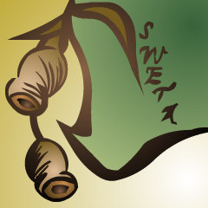

**Practice Western Australian Certificate of Education**

**ATAR course examination, 2017**

**Question/Answer booklet**

**YEAR 12**

**ATAR ENGLISH**

Place your student identification label in this box.

Student number: In figures

In words ________________________________________

________________________________________

**Time allowed for this paper**

Reading time before commencing work: ten minutes

Working time: three hours

Number of additional

answer booklets used

(if applicable)

**Materials required/recommended for this paper**

**To be provided by the supervisor**

This Question/Answer booklet

**To be provided by the candidate**

Standard items: pens (blue/black preferred), pencils (including coloured), sharpener, correction fluid/tape, eraser, ruler, highlighters

Special items: nil

**Important note to candidates**

No other items may be taken into the examination room. It is **your** responsibility to ensure that you do not have any unauthorised material. If you have any unauthorised material with you, hand it to the supervisor **before** reading any further.

**Structure of this paper**

|  |  |  |  |  |  |
| --- | --- | --- | --- | --- | --- |
| Section | Number of questions available | Number of questions to be answered | Suggested working time (minutes) | Marks available | Percentage of examination |
| Section One  Comprehending | 3 | 3 | 60 | 30 | 30 |
| Section Two Responding | 6 | 1 | 60 | 40 | 40 |
| Section Three Composing | 5 | 1 | 60 | 30 | 30 |
|  |  |  |  | **Total** | 100 |

**Instructions to candidates**

1. The rules for the conduct of the Western Australian Certificate of Education ATAR course examinations are detailed in the *Year 12 Information Handbook 2017.* Sitting this examination implies that you agree to abide by these rules.
2. Write your answers in the Question/Answer booklet.
3. You must be careful to confine your answers to the specific questions asked and to follow any instructions that are specific to a particular question. If you fail to comply you will be penalised.
4. Additional working space pages at the end of this Question/Answer booklet are for planning or continuing an answer. If you use these pages, indicate at the original answer, the page number it is planned/continued on and write the question number being planned/continued on the additional working space page.

**Section One: Comprehending 30% (30 Marks)**

In this section, there are **three** texts and **three** questions. Answer **all** questions.

You are required to comprehend and analyse unseen written and visual texts and respond concisely in approximately 200-300 words for each question.

Suggested working time: 60 minutes.

**Question 1 (10 Marks)**

Discuss how authorial voice positions readers to respond to a particular group in **Text 1.**

**Question 2 (10 Marks)**

Comment on how the author has presented a particular perspective on an issue in **Text 2**.

**Question 3 (10 Marks)**

Compare how **Text 2** and **Text 3** utilises techniques to comment on Australian identity.

**Text 1**

This passage is an extract from the John Steinbeck novel The Grapes Of Wrath and is set during the 1930s Great Depression (when one in four people were out of work) in the USA.

The works of the roots of the vines, of the trees, must be destroyed to keep up the price, and this is the saddest, bitterest thing of all. Car-loads of oranges dumped on the ground. The people came for miles to take the fruit, but this could not be. How would they buy oranges at twenty cents a dozen if they could drive out and pick them up? And men with hoses squirt kerosene on the oranges, and they are angry at the crime, angry at the people who have come to take the fruit. A million people hungry, needing the fruit – and kerosene sprayed over the golden mountains.

And the smell of rot fills the country.

Burn coffee for fuel in the ships. Burn corn to keep warm, it makes a hot fire.

Dump potatoes in the rivers and place guards along the banks to keep the hungry people from fishing them out.

Slaughter the pigs and bury them, and let the putrescence drip down into the earth.

There is a crime here that goes beyond denunciation. There is a sorrow here that weeping cannot symbolise. There is a failure here that topples all our success. The fertile earth, the straight tree rows, the sturdy trunks, and the ripe fruit. And children dying of pellagra¹ must die because a profit cannot be taken from an orange. And coroners must fill in the certificates – died of malnutrition – because the food must rot, must be forced to rot.

The people come with nets to fish for potatoes in the river, and the guards hold them back; they come in rattling cars to get the dumped oranges, but the kerosene is sprayed. And they stand still and watch the potatoes float by, listen to the screaming pigs being killed in a ditch and covered with quicklime, watch the mountains of oranges slop down to a putrefying ooze; and in the eyes of the people there is the failure; and in the eyes of the hungry there is a growing wrath². In the souls of the people the grapes of wrath are filling and growing heavy, growing heavy for the vintage.

________________________

1. Pellagra: deadly disease caused by dietary deficiency.

2. Wrath: taking revenge as a result of anger.

**Text 2**

This passage is an edited extract from an article entitled “Why do we erase people of colour from national myths?” by Nehal Kale, published in The Guardian.com 29th March 2017.

Here [in Australia], the ANZACS, World War One soldiers whose legend epitomised mateship and resilience — qualities that went on to define national identity for generations — are enshrined in our cultural consciousness as Anglo-Australian. This overlooks the nearly 400 Indigenous Australians that also fought for the British Empire against the Germans and Turks, returning, as Paul Daley points out in a [January 2014 article in The Guardian](https://www.theguardian.com/commentisfree/2014/dec/05/black-digger-a-challenge-to-australias-reverence-for-a-white-anzac-legend), to discover that their ancestral lands had been divided and allocated.

Around 50 years before that, the Chinese settlers who flocked to Ballarat also helped build hospitals and orphanages, went on to [establish the Chinese Goldfields League in 1882 — a series of teams that (you heard right) played some of the first-ever games of AFL.](https://www.theguardian.com/sport/blog/2015/mar/25/forgotten-story-chinese-goldfields-aussie-rules) Sure, the League dissolved when the White Australia Policy was introduced in 1901. But isn’t it nice to think that Australianness didn’t manifest as a barbed-wire fence between “us” and “them” but as something more malleable and expansive, even if it was for one fleeting historical second?

Culture likes us to perpetuate capital H History, the single story that the novelist Chimamanda Ngozie Adichie warns against in her [famous 2016 TED Talk](https://www.ted.com/talks/chimamanda_adichie_the_danger_of_a_single_story). But in a world in which whiteness dictates who gets to be an insider and who’s considered an outsider and far-right parties use a whitewashed past as evidence of national greatness, there’s power in acknowledging our mixed-up histories, our endlessly tangled roots.

After all, xenophobia and Islamophobia are premised on the notion that people of colour are always recent arrivals, strangers to the country’s legacies and traditions — it pays to remind ourselves, it’s often manufactured to spark longing for a racial purity that never really existed. As Amir Hussain [points out in a January 2017 article in Religion and Politics](http://religionandpolitics.org/2017/01/30/there-has-never-been-an-america-without-muslims/), Muslims lived in America “more than 90 years before the pilgrims arrived and some two centuries before most of the founding fathers were born” but it’s a history that’s been “overlooked, forgotten and purposefully dismissed”.

**Text 3**

This text shows Cathy Freeman’s celebration of winning the gold medal in the 400 metre race at the 2000 Sydney Olympics by waving both the Australian and the Aboriginal flag.

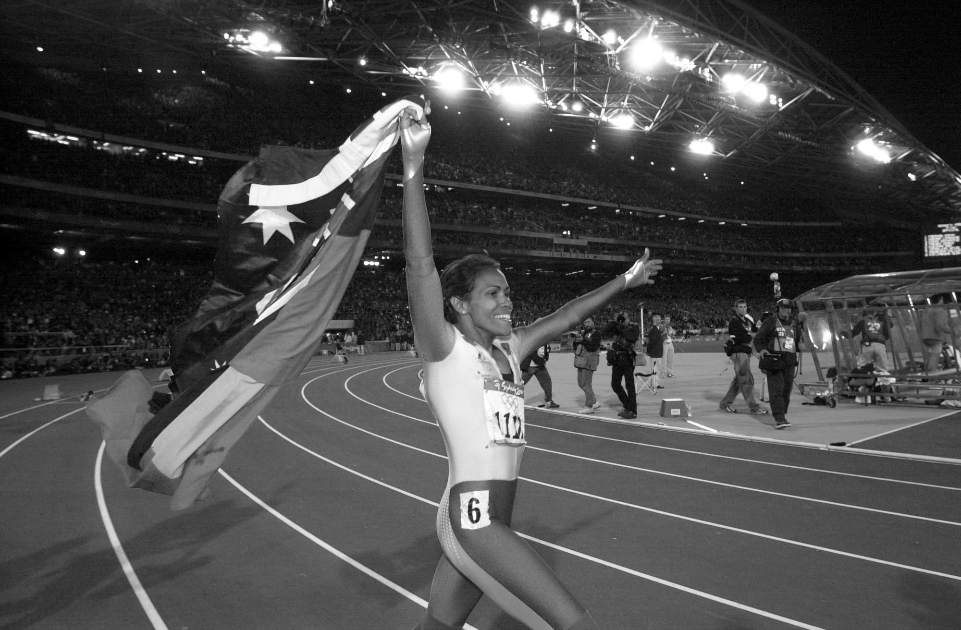

**End of Section One**

**Section Two: Responding 40% (40 Marks)**

In this section, there are **six** questions. Answer **one** question.

In the form of an **essay**, your response should demonstrate your analytical and critical thinking skills with reference to any text or text type you have studied.

Suggested working time: 60 minutes.

**Question 4 (40 Marks)**

Compare the ways different perspectives have been used, in at least **two** texts studied, to highlight the need for change in society.

**Question 5 (40 Marks)**

Discuss how interpretive texts seek to challenge or reinforce dominant attitudes in at least **one** text studied.

**Question 6 (40 Marks)**

In at least **two** texts studied, compare how style or structure effectively conveys ideas.

**Question 7 (40 Marks)**

“For me, the main inspiration to write a story or novel is the voice of its central character, or the narrative voice of the story itself.” (Scott Bradfield).

With reference to at least **one** text studied, argue that voice is integral to the understanding of texts.

**Question 8 (40 Marks)**

The conventions of genre can be adhered to or broken to have a desired impact on an audience.

Discuss with reference to at least **one** text studied.

**Question 9 (40 Marks)**

Explain how context can impact on the possible readings that can be made of at least **one** text studied.

**End of Section Two**

**Section Three: Composing 30% (30 Marks)**

In this section, there are **five** questions. Answer **one** question.

You are required to demonstrate writing skills by choosing a form of writing appropriate to a specific audience, context and purpose.

Suggested working time: 60 minutes.

**Question 10 (30 Marks)**

“Don't judge each day by the harvest you reap, but by the seeds you plant.” (Robert Louis Stevenson).

Create an argument in response to the above prompt.

**Question 11 (30 Marks)**

Compose a narrative that uses voice to create a particular effect.

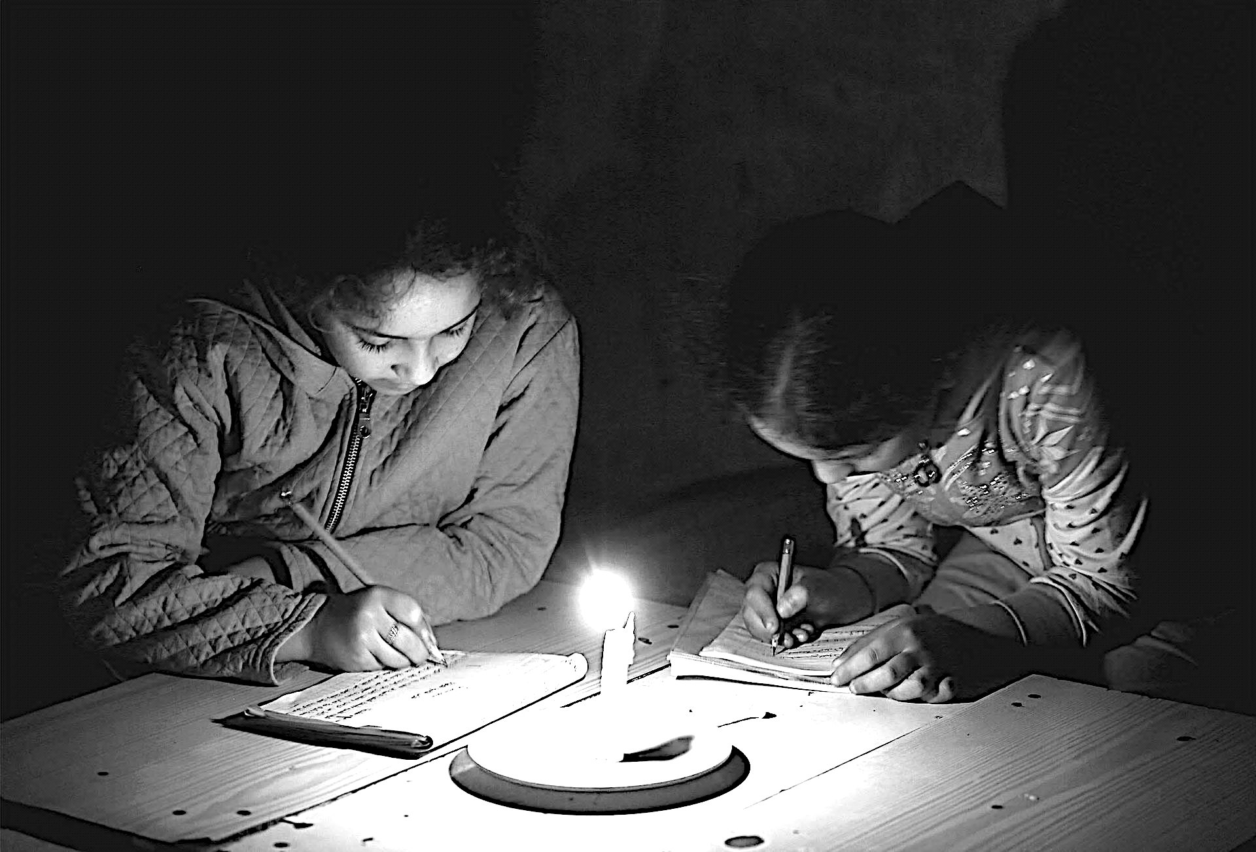

**Question 12 (30 Marks)**

“You may choose to look the other way but you can never say again that you did not know.” (William Wilberforce).

Write a text in any form that incorporates the above prompt in relation to a controversial issue in modern society.

**Question 13 (30 Marks)**

Write a text that agrees or disagrees with the proposition that language is used to include or exclude.

**Question 14 (30 Marks)**

Using the image below as inspiration, write a text which employs the stylistic features of a particular genre.



**End of questions**

**ACKNOWLEDGEMENTS**

**Text 1**

Steinbeck, John. 2000. *The Grapes of Wrath*. Great Britain: Penguin Classics.

**Text 2**

Retrieved April 2017

http://www.sbs.com.au/topics/life/culture/article/2017/03/29/comment-why-do-we-erase-people-colour-national-myths

**Text 3**

Retrieved May 2017

http://www.sbs.com.au/news/sites/sbs.com.au.news/files/freeman_2000_aap.jpg

**Question 11**

Retrieved May 2017

https://www.theguardian.com/news/gallery/2017/apr/24/best-photos-of-the-day-racist-insults-and-a-mini-merkel#img-12

**Question 14**

Retrieved March 2017

https://thebestpictureproject.files.wordpress.com/2012/03/metropolis3.jpg

Copyright **©** South West English Teachers’ Association 2017.